The Serif kittens:

[](https://en.wikipedia.org/wiki/File:Times_New_Roman_font.svg)

Times is very famous, and has many admirers

[](https://en.wikipedia.org/wiki/File:Constantia_font.svg)

While Constantia is practical and bold

[](https://en.wikipedia.org/wiki/File:Alexandria_font.svg)

May be a bit nerdy, but can still show its flair

The cursive kittens:

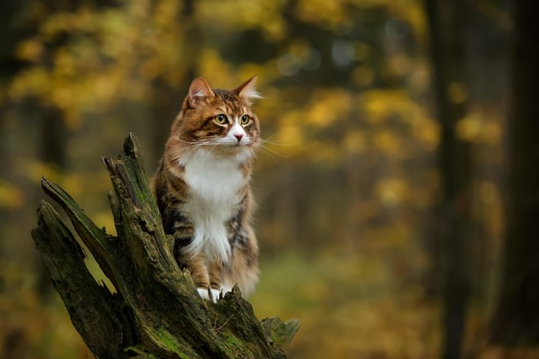

<https://cdn.uniguide.com/wp-content/uploads/2021/06/cat-symbolism-meaning-forest-cat.jpg>

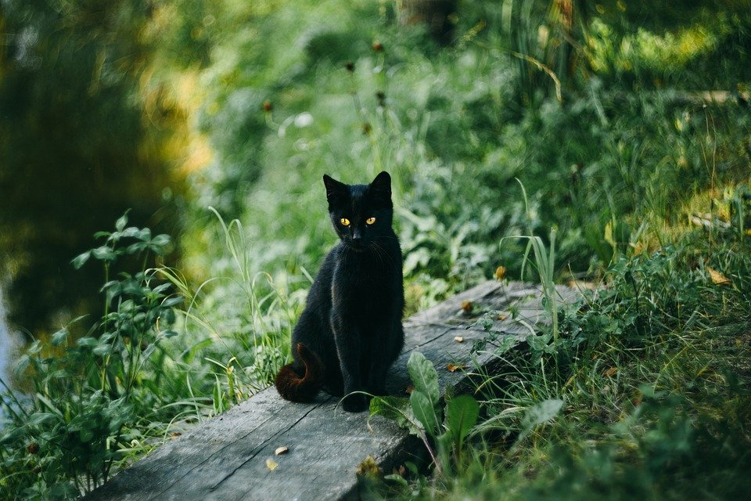

<https://cdn.pixabay.com/photo/2017/11/11/17/40/cat-2939726_960_720.jpg>

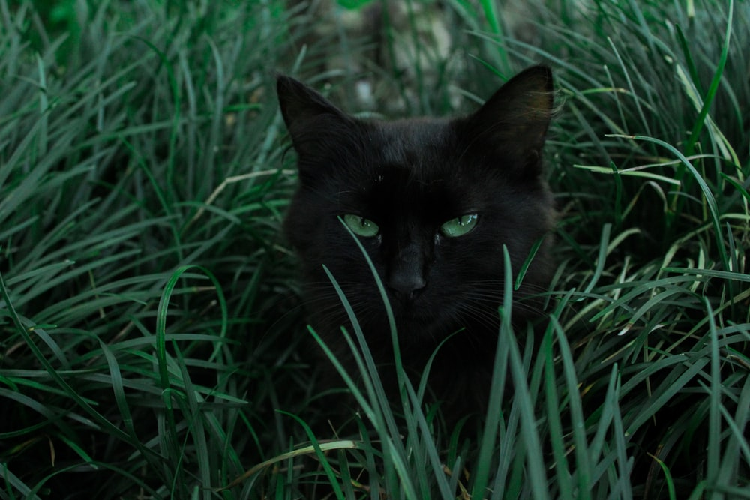

<https://images.unsplash.com/photo-1516280030429-27679b3dc9cf?ixid=MnwxMjA3fDB8MHxzZWFyY2h8MXx8YmxhY2slMjBhbmltYWx8ZW58MHx8MHx8&ixlib=rb-1.2.1&w=1000&q=80>

https://egyptianstreets.com/wp-content/uploads/2020/12/7aa4e5d26a5bfc54f4f1737266603e91.v1.jpg

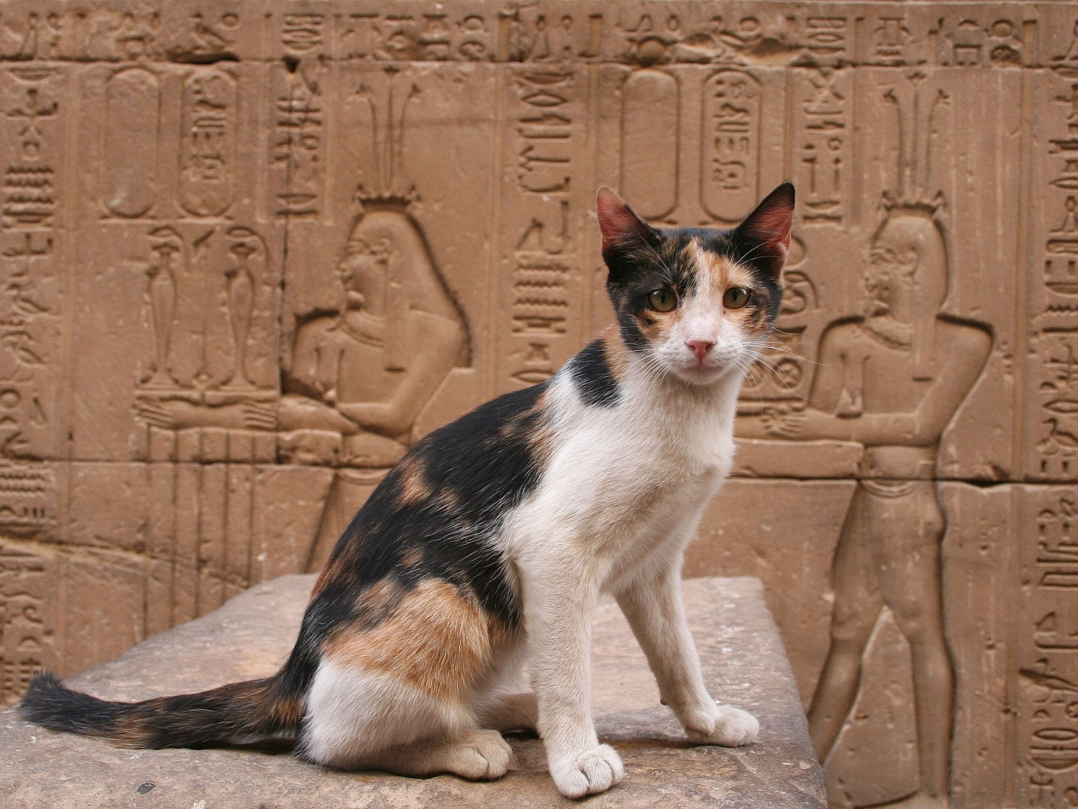

https://www.thesprucepets.com/thmb/7rS4xxD6huOCPxTZe0pq1f0jMio=/3072x2304/smart/filters:no_upscale()/GettyImages-608972797-96e92b429f234b6c9eccd90084acd646.jpg

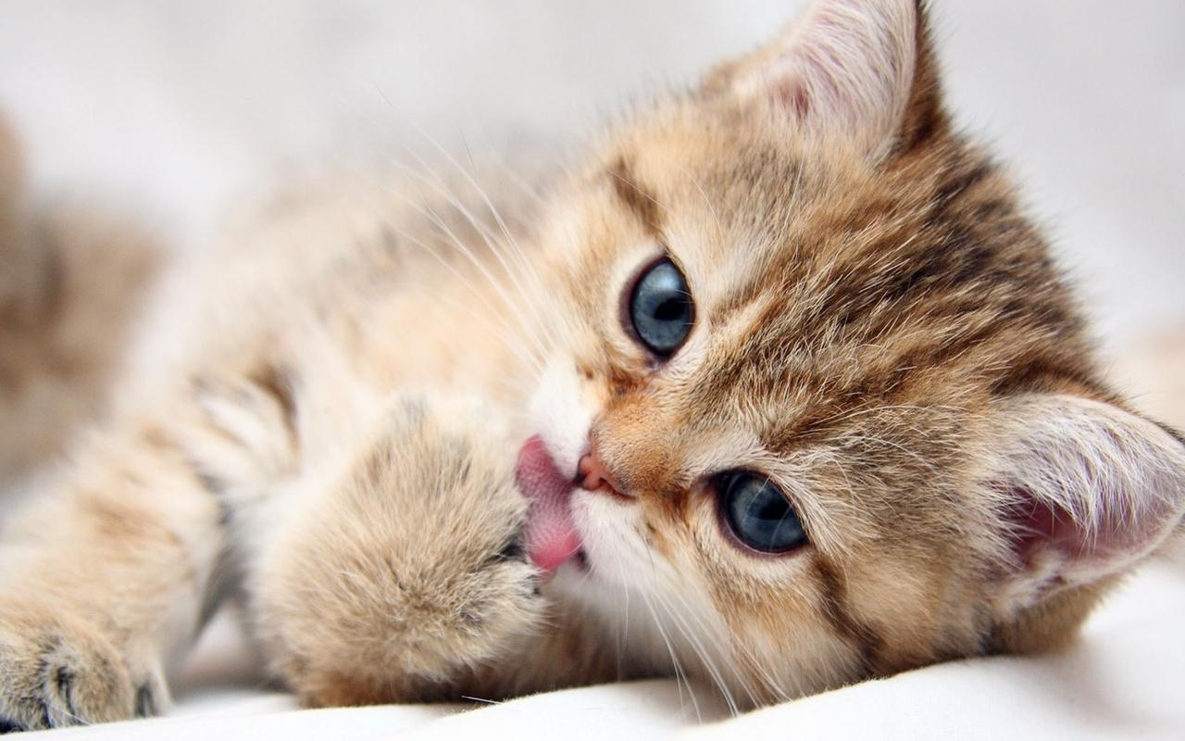

https://wallpaperaccess.com/full/374174.jpg

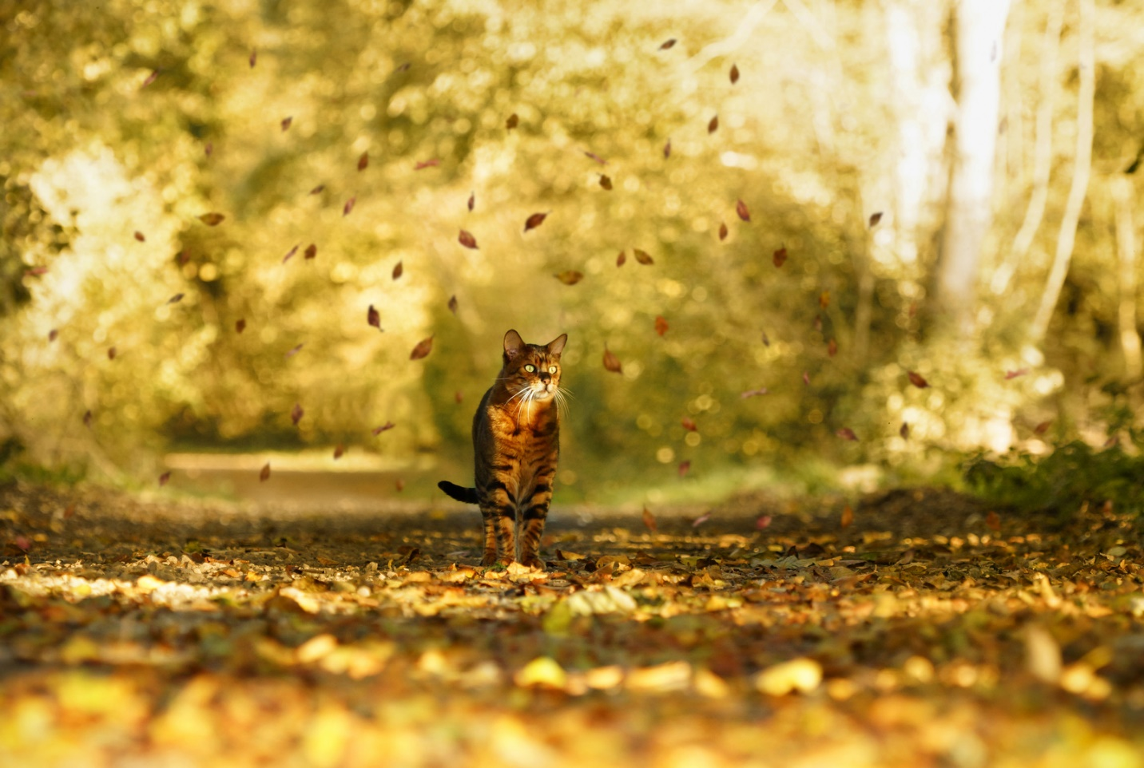

https://img.fotocommunity.com/the-cat-is-natures-beauty-c28e6912-299e-44fd-ba55-ad335d6235e9.jpg?height=1080

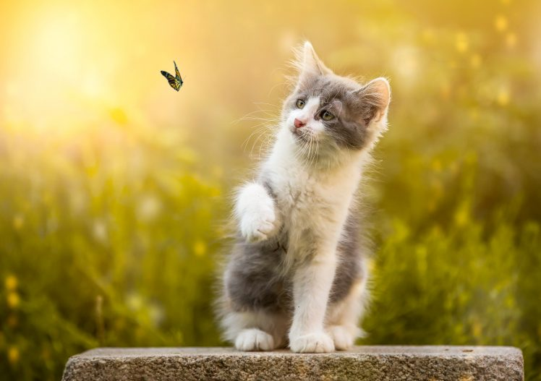

<https://wallup.net/wp-content/uploads/2018/03/19/578332-cat-animals-insect-nature-butterfly-748x527.jpg>

[](https://en.wikipedia.org/wiki/File:Kuenstler_Script.svg)

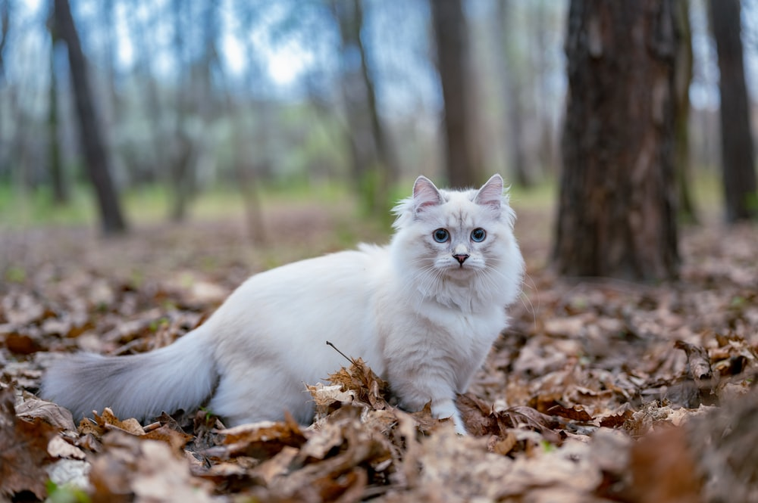

<https://images.unsplash.com/photo-1620072888881-c0f56753769c?ixid=MnwxMjA3fDB8MHxzZWFyY2h8M3x8Zm9yZXN0JTIwY2F0fGVufDB8fDB8fA%3D%3D&ixlib=rb-1.2.1&w=1000&q=80>

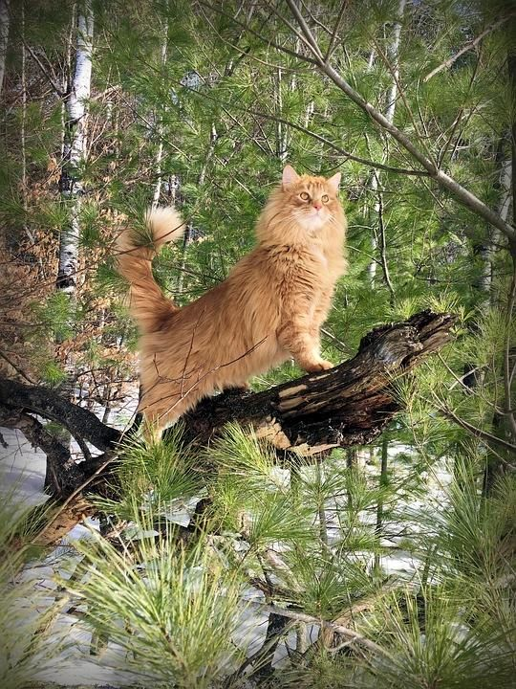

https://i.pinimg.com/564x/f0/f3/fc/f0f3fc234dad43521f3ffcb6c6d13ed6.jpg

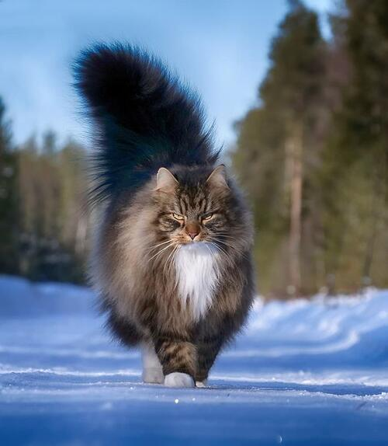

https://ap-pics2.gotpoem.com/ap-pics/item/15216/325.jpg?

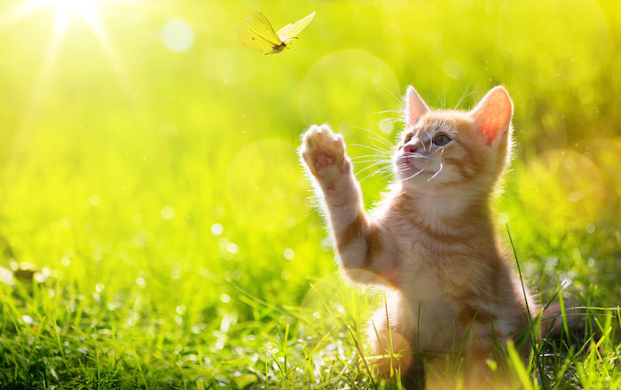

https://www.spiritanimal.info/pictures/cat/Cat-Spirit-Animal-6.jpg

http://7-themes.com/6907818-cat-nature.html

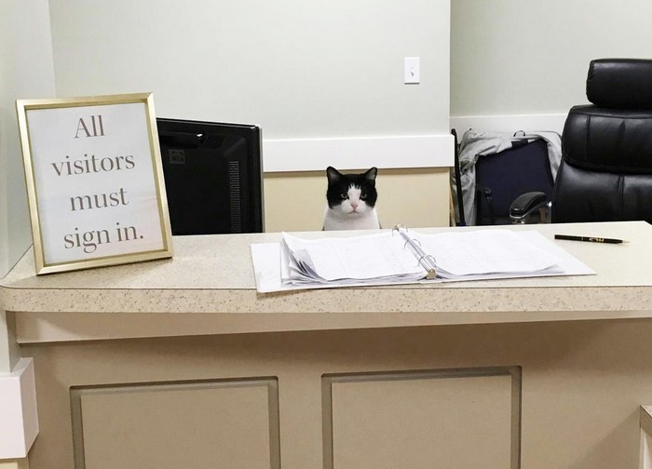

<https://static.boredpanda.com/blog/wp-content/uploads/2019/06/cat-working-10-5d14cccb88c6d__700.jpg>

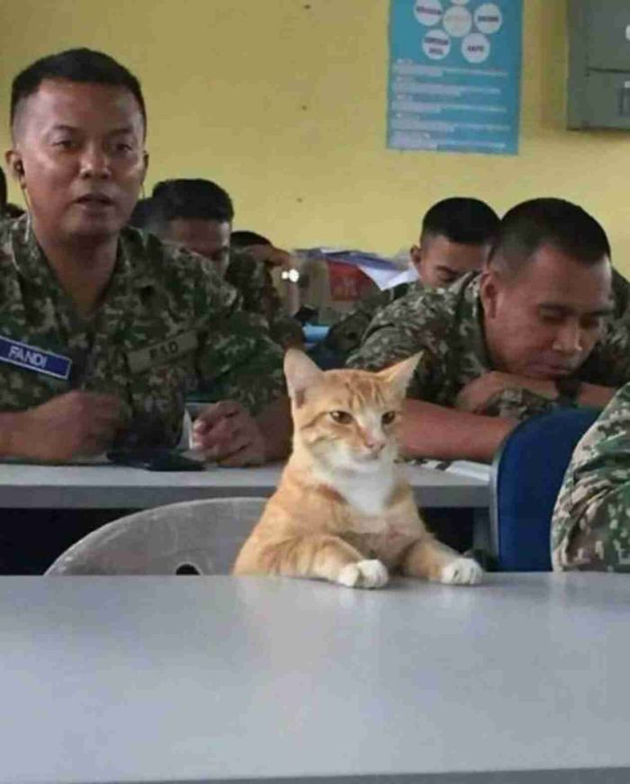

<https://static.boredpanda.com/blog/wp-content/uploads/2019/06/CLUSgvzXe1BIjzI_x5fKc_15-5d14bc47e8ca6-jpeg__700.jpg>



<https://static.boredpanda.com/blog/wp-content/uploads/2019/06/5d14c6022c7e9_beuys3g184631__700.jpg>

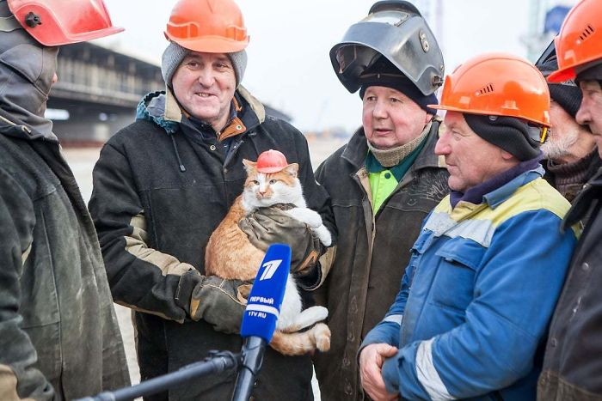

<https://static.boredpanda.com/blog/wp-content/uploads/2019/06/5d14d31f2f3c2_kbfdphaobcy01__700.jpg>

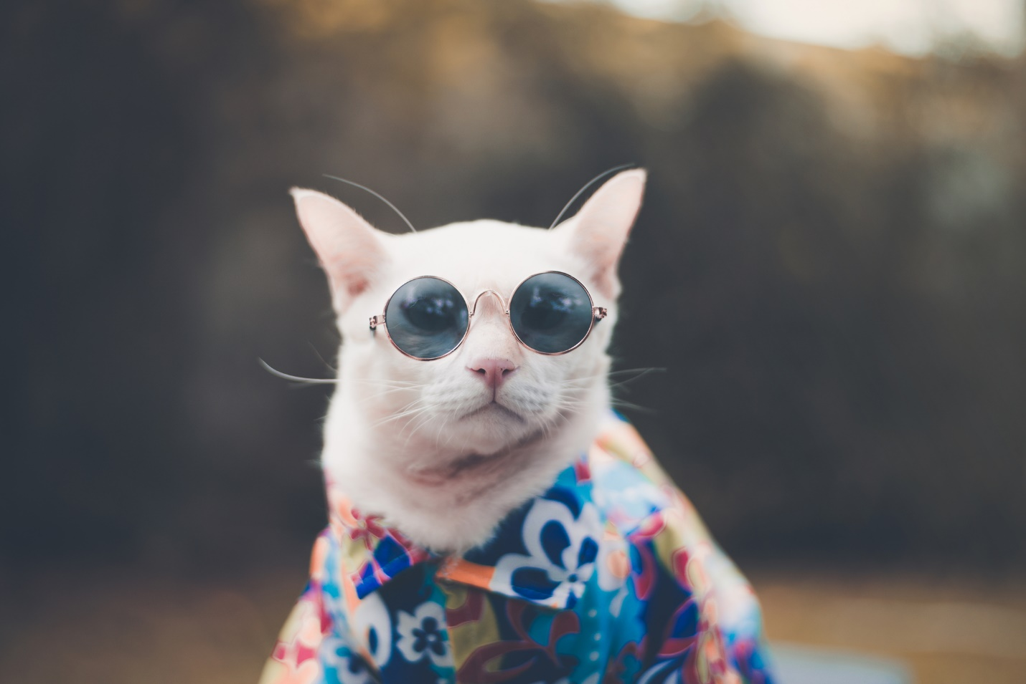

<http://frontpagemeews.com/wp-content/uploads/2019/08/iStock-1071075930.jpg>

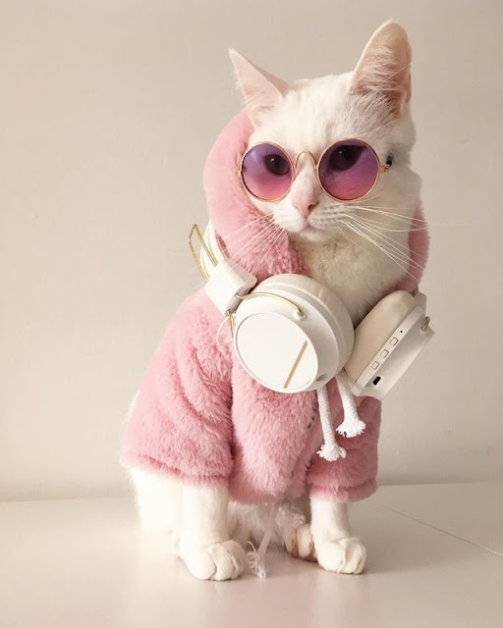

Allison

<https://1.bp.blogspot.com/-bqQ--iQpVw8/Xz-C8qn5VNI/AAAAAAAADek/dkUVeKwFxiANkZsx_EMieq1YVZt23TnPQCLcBGAsYHQ/s640/cat%2Bfashion.jpg>

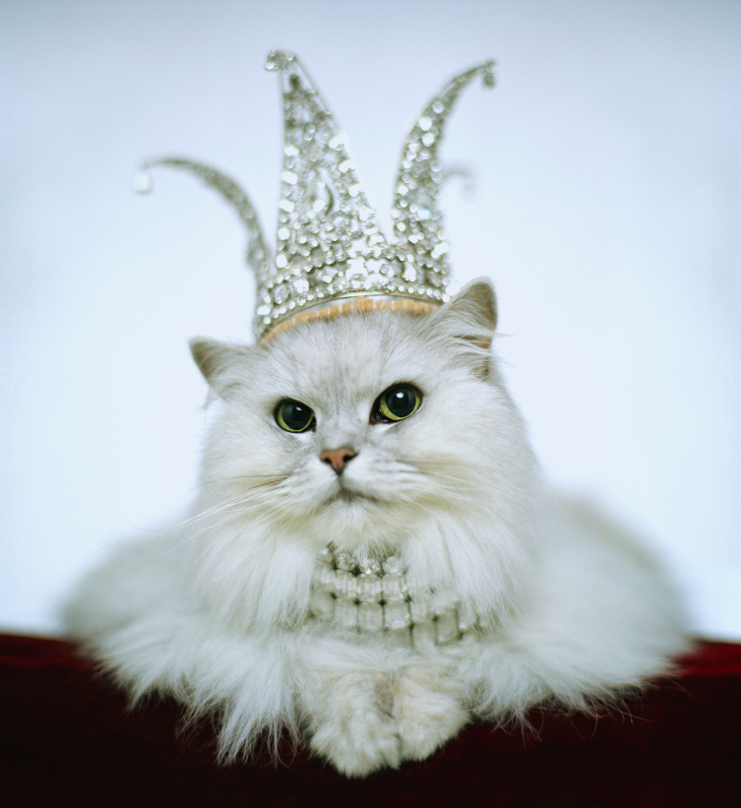

https://brokeass2-9uzlt3u.netdna-ssl.com/wp-content/pictsnShit/2019/01/bezos-rich-cat-crown.png

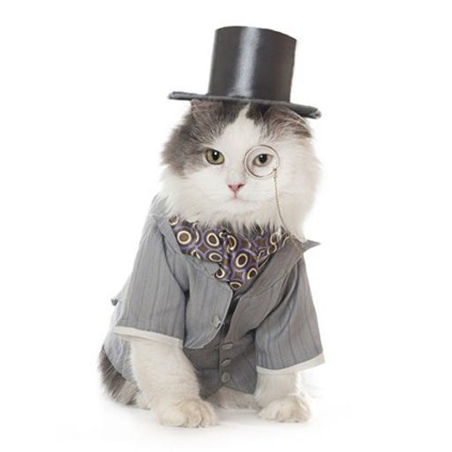

<https://lh3.googleusercontent.com/RgBBsuzkQsARAE2_yqITBRAyQlgyWmzYTqscNBZN6DHI-52qOywwZuebjRJjcGb6kPc>

a beautiful gray cat with green eyes on a dark background with books. Purebred Russian blue cat (Getty Images)


https://www.eastbaytimes.com/wp-content/uploads/2018/10/GettyImages-6829647242.jpg?w=1080